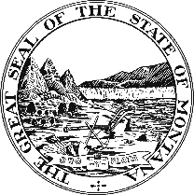NOTICE OF PUBLIC MEETING
ARPA COMMUNICATIONS ADVISORY COMMISSION
P.O. Box 200101, Helena, MT 59620-0101 / (406) 444-2460

Location: Capitol Building or Zoom
Watch & Listen Online
1301 E. 6th Avenue, Room 152, Helena, MT 59601

AGENDA*
Tuesday, November 1st @ 1:00 PM

1. OPEN MEETING – 1:00 PM Sen. Jason Ellsworth, Chair
a. Call to Order and Notice of Audio / Video Recording
b. Roll Call and Proxies

2. ARPA PROGRAM UPDATE – 1:05 PM Scott Mendenhall, ARPA Director
a. Expense Forms
b. ARPA Website and Transparency
c. Federal Infrastructure Funding Update Misty Giles, Director of DOA
d. Inflationary Impacts Russ Katherman, State Architect, DOA

3. APPLICATION RANKINGS – 1:20 PM Sen. Jason Ellsworth, Chair

4. COMMISSION DISCUSSION – 1:30 PM Sen. Jason Ellsworth, Chair

5. PUBLIC COMMENT – 1:45 PM Sen. Jason Ellsworth, Chair

6. OTHER – 2:00 PM
a. Future Meeting Dates

7. ADJOURN – 2:30 PM

* This agenda is subject to modification up to 24 hours in advance of the start of the meeting. Agenda, handouts, past meeting information is available online at Home (mt.gov)

