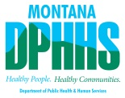

Department of Public Health and Human Services
Montana Medicaid Virtual Public Hearing
New Montana Medicaid Healing and Ending Addiction through Recovery and Treatment (HEART) Waiver Application

Wednesday, July 21, 2021, 10:00 a.m. – 12:00 p.m.

Register here
You will receive instructions for joining the meeting upon registration. If special accommodations are needed, contact Mary Eve Kulawik at (406) 444-2584 or mkulawik@mt.gov.

Welcome and Introductions

DPHHS HEART Waiver Presentation

Public Comment

Adjourn

